For Academic Affairs and Research Use Only
CIP Code:
Degree Code:

Reconfiguration of Existing Degree Program Proposal Form
[ ] Undergraduate Curriculum Council
[X] Graduate Council
Signed paper copies of proposals submitted for consideration are no longer required. Please type approver name and enter date of approval.
Email completed proposals to curriculum@astate.edu for inclusion in curriculum committee agenda.
Edward Hammerand 9/27/2017  Department Curriculum Committee Chair | Rob Williams 10/25/2017  COPE Chair (if applicable)
Hung-Chi Su 9/27/2017  Department Chair: | Mary Jane Bradley 10/25/2017  Head of Unit (If applicable)
David F. Gilmore 10/6/2017  College Curriculum Committee Chair | __________________ Enter date  Undergraduate Curriculum Council Chair
Anne A. Grippo 10/6/2017  College Dean | __________________ Enter date  Graduate Curriculum Committee Chair
__________________ Enter date  General Education Committee Chair (If applicable) | __________________ Enter date  Vice Chancellor for Academic Affairs

- Proposed Program Title
Graduate Certificate in Computer Science Education

- Contact Person (Name, Email Address, Phone Number)
Dr. Hung-Chi Su, suh@astate.edu, 870-680-8119

- Proposed Starting Date
8/15/2018

- Is there differential tuition requested? If yes, please fill out the New Program/Tuition and Fees Change Form.
No
Bulletin Changes

Instructions
Please visit http://www.astate.edu/a/registrar/students/bulletins/index.dot and select the most recent version of the bulletin. Copy and paste all bulletin pages this proposal affects below. Follow the following guidelines for indicating necessary changes.

*Please note: Courses are often listed in multiple sections of the bulletin. To ensure that all affected sections have been located, please search the bulletin (ctrl+F) for the appropriate courses before submission of this form.

- Deleted courses/credit hours should be marked with a red strike-through (red strikethrough)
- New credit hours and text changes should be listed in blue using enlarged font (blue using enlarged font).
- Any new courses should be listed in blue bold italics using enlarged font (blue bold italics using enlarged font)

You can easily apply any of these changes by selecting the example text in the instructions above, double-clicking the ‘format painter’ icon , and selecting the text you would like to apply the change to.
Please visit https://youtu.be/yjdL2n4lZm4 for more detailed instructions.

*For new programs, please insert copy of all sections where this is referenced.*
Insert on page 52 of 2017-18 Graduate Bulletin under Graduate Certificates:

Educational Leadership
—Building Level Administration
—Curriculum Director
—Gifted, Talented and Creative Director
—Instructional Specialist - Gifted, Talented
and Creative
—K-12 Special Education
—Special Education Director
Dyslexia Therapy
History
Health Care Management
Health Communication
Healthcare Emergency Management
Health Sciences Education
Clinical Mental Health Counseling
Nurse Educator
Play Therapy
Computer Science Education

Insert on page 244 of 2017-18 Graduate Bulletin:

The College of Sciences and Mathematics offers work leading to the Master of Arts degree in biology; to the Master of Science degree with majors in biology, chemistry, computer science, environmental sciences, and mathematics; to the Master of Science in molecular biosciences; to the Master of Science in Education degree with majors in biology, chemistry, and mathematics; and to the Graduate Certificate in Computer Science Education.

Insert on page 262 of 2017-2018 Graduate Bulletin after Program of Study for Computer Science:
Computer Science Education
Graduate Certificate
University Requirements:
See Graduate Degree Policies for additional information (p. 35)
Requirements: | Sem. Hrs.
ELFN 6763, Philosophies of Education OR  PSY 6513, Advanced Educational Psychology | 3
CSED 5043 Principles of Computer Programming | 3
CSED 5731 Principles of Abstract Structures | 1
CSED 5231 Principles of Operating Systems | 1
CSED 5241 Principles of Computer Organization | 1
Electives: | Sem. Hrs.
Select six hours from the following:  CS 5223 UNIX Systems Programming  CS 5313 Computer Networks  CS 5543 Database Systems | 6
Total Required Hours: | 15

LETTER OF NOTIFICATION – 11
RECONFIGURATION OF EXISTING DEGREE PROGRAMS
(Consolidation or Separation of Degrees to Create New Degree)
*Please include the documents to be submitted found throughout this LON at the end of the form.

- Institution submitting request: Arkansas State University

- Contact person/title: Dr. Hung-Chi Su, Chair of Computer Science Department

- Title(s) of degree programs to be consolidated/reconfigured:
Master of Science in Computer Science

- Current CIP Code(s)/Current Degree Code(s): 11.0101

- Proposed title of consolidated/reconfigured program:
Graduate Certificate in Computer Science Education
- Proposed CIP Code for new program: 13.1321
- Proposed Effective Date: August 15, 2018

- Reason for proposed program consolidation/reconfiguration:
(Indicate student demand (projected enrollment) for the proposed program and document that the program meets employer needs)

The program has been designed to accommodate an anticipated initial enrollment at launch of five to ten students with a slow increase after that. This is in part due to the logistical demands of pursuing the degree placed on in-service teachers, who make up the potential student body. As the program develops, methods of offering at least some of the course work online are being considered to grow the program further.

Documenting that the program meets employer needs:
“Arkansas Governor Hutchinson has overseen passage of the first truly comprehensive law requiring all public and charter high schools to offer computer sciences courses to students, beating better known tech centers like California and New York to the punch.”
https://www.wired.com/2015/03/arkansas-computer-science/

“Arkansas, for example, is scrambling to hire and train enough qualified teachers. As Arkansas Governor Asa Hutchinson stated at the time the new mandate became law, only 20 high school teachers across the entire state were actually prepared to teach computer science.“

http://fortune.com/2015/10/22/u-s-students-computer-science/

The Arkansas Department of Education designated the following as critical academic shortage areas for the 2016-2017 school year: Computer Science.

http://www.arkansased.gov/public/userfiles/HR_and_Educator_Effectiveness/HR_Educator_Licensure/CSA_PPT_from_Dec_2015_FINAL_with_Notes-11266.pdf

“Successful implementation of computer science standards may hinge on one thing: teacher capacity. Without enough qualified teachers and the resources to support them, states will be hard pressed to make computer science a part of every student’s education—something that industry leaders say is critical to career readiness.”

http://www.nasbe.org/state-innovation/preparing-computer-science-teachers-in-maryland-and-arkansas/

U.S. Department of Education Teacher Shortage Areas Nationwide Listing 2016-2017 Arkansas: Computer Science

https://www2.ed.gov/about/offices/list/ope/pol/tsa.pdf

- Provide current and proposed curriculum outline by semester.
For undergraduate programs, please also fill out 8-semester plan at end of document.
Indicate total semester credit hours required for the proposed program. Underline new courses and provide new course descriptions. (If existing courses have been modified to create new courses, provide the course name/description for the current/existing courses and indicate the related new/modified courses.) Identify required general education core courses with an asterisk.

Current M.S. in Computer Science Curriculum |  | Credit Hours
Algorithms: |  | 3
CS 5713 | Algorithms
Theory (select one of the following): |  | 3
CS 5133 | Compilers
CS 5723 | Automata Theory
Systems (select one of the following): |  | 3
CS 5313 | Computer Networks
CS 6213 | Parallel Processing
CS 6223 | High Performance Computing
CS 6233 | Distributed Systems
Computer Science Electives (Choose 18 hours)
 | including CS courses such as:  CS 5223 UNIX Systems Programming  CS 5313 Computer Networks  CS 5543 Database Systems | 18
Computer Science, Mathematics, and/or Statistics Electives |  | 6
Total Credit Hours |  | 33

Proposed Graduate Certificate in Computer Science Education Curriculum |  | Credit Hours
CSED 5043 | Principles of Computer Programming | 3
CSED 5731 | Principles of Abstract Structures | 1
CSED 5231 | Principles of Operating Systems | 1
CSED 5241 | Principles of Computer Organization | 1
Select Two of the Following: |  | 6
CS 5223 | UNIX Systems Programming
CS 5313 | Computer Networks
CS 5543 | Database Systems
Select One of the Following: |  | 3
ELFN 6763 | Philosophies of Education
PSY 6513 | Advanced Educational Psychology
Total Credit Hours |  | 15

Propose Certificate in Computer Science Education Schedule |  | Credit Hours
Fall Semester |  | 3
CSED 5043 | Principles of Computer Programming
Spring Semester |  | 3
CSED 5731 | Principles of Abstract Structures
CSED 5231 | Principles of Operating Systems
CSED 5241 | Principles of Computer Organization
Summer Semester |  | 3
ELFN 6763 or PSY 6513 | Philosophies of Education  Advanced Educational Psychology
Fall Semester |  | 3
CS elective (one of three)
Spring Semester |  | 3
CS elective (one of three)
Total Credit Hours |  | 15
New courses:
- CSED 5043. Principles of Computer Programming (originated as subject in CS5012 & CS5022 & CS5032 accelerated programming and data structures courses)
Programming methodology, procedural abstraction, top-down design, object-oriented programming techniques, fundamental data structures such as linked lists, stacks, queues and binary trees, searching and sorting techniques, and an introduction to algorithm analysis, all with an emphasis on pedagogy in the secondary school.

- CSED 5731, Principles of Abstract Structures (originated as subject in undergraduate special course CS482V)
Foundational computer science concepts, including algorithm complexity and structures such as sets, trees, and graphs, with an emphasis on pedagogy in the secondary school.

- CSED 5231, Principles of Operating Systems (originated as subject in undergraduate special course CS482V)
Policies, design issues, and implementation techniques for operating system software with an emphasis on pedagogy in the secondary school.

- CSED 5241, Principles of Computer Organization
Basic principles of computer architectural design with an emphasis on pedagogy in the secondary school.

- Provide program budget. Indicate amount of funds available for reallocation.
See end of document.

- Provide current and proposed organizational chart. See end of document.

- Institutional curriculum committee review/approval date: Enter text...

- Are the existing degrees offered off-campus or via distance delivery?
No

- Will the proposed degree be offered on-campus, off-campus, or via distance delivery?
On-campus

- Identify mode of distance delivery or the off-campus location for the proposed program.
N/A

- Provide documentation that proposed program has received full approval by licensure/certification entity, if required.
(A program offered for teacher/education administrator licensure must be reviewed/approved by the Arkansas Department of Education prior to consideration by the Coordinating Board; therefore, the Education Protocol Form also must be submitted to ADHE along with the Letter of Notification).

N/A, program does not lead to licensure/certification

- Provide copy of e-mail notification to other institutions in the area of the proposed program and their responses; include your reply to the institutional responses. See end of document.

- List institutions offering similar program and identify the institutions used as a model to develop the proposed program.
The College of St. Scholastica

Model used to develop program was the A-State M.S. in Computer Science program

- Provide scheduled program review date (within 10 years of program implementation).
Spring 2028

- Provide additional program information if requested by ADHE staff.
Enter text...

President/Chancellor Approval Date: Click here to enter a date.
Board of Trustees Notification Date: Click here to enter a date.

Chief Academic officer: ___________________________________ Date: Enter date.
Name (printed): Click here to enter text.

8-Semester Plan
(referenced in #9 - Undergraduate Proposals Only)
Instructions: Please identify new courses in italics.
Arkansas State University-Jonesboro Degree:
Major:
Year:

Students requiring developmental course work based on low entrance exam scores (ACT, SAT, ASSET, COMPASS) may not be able to complete this program of study in eight (8) semesters. Developmental courses do not count toward total degree hours. Students having completed college level courses prior to enrollment will be assisted by their advisor in making appropriate substitutions. In most cases, general education courses may be interchanged between semesters. A minimum of 45 hours of upper division credit (3000-4000 level) is required for this degree.
Year 1 |  |  |  |  | Year 1
Fall Semester |  |  |  |  | Spring Semester
Course No. | Course Name | Hrs | Gen Ed |  | Course No. | Course Name | Hrs | Gen Ed
Total Hours |  |  |  |  | Total Hours
Year 2 |  |  |  |  | Year 2
Fall Semester |  |  |  |  | Spring Semester
Course No. | Course Name | Hrs | Gen Ed |  | Course No. | Course Name | Hrs | Gen Ed
Total Hours |  |  |  |  | Total Hours
Year 3 |  |  |  |  | Year 3
Fall Semester |  |  |  |  | Spring Semester
Course No. | Course Name | Hrs | Gen Ed |  | Course No. | Course Name | Hrs | Gen Ed
Total Hours |  |  |  |  | Total Hours
Year 4 |  |  |  |  | Year 4
Fall Semester |  |  |  |  | Spring Semester
Course No. | Course Name | Hrs | Gen Ed |  | Course No. | Course Name | Hrs | Gen Ed
Total Hours |  |  |  |  | Total Hours
Total Jr/Sr Hours ___ Total Degree Hours ___
Graduation Requirements:

Program Budget
(referenced in # 10)

Provide program budget. Indicate amount of funds available for reallocation.

Courses required will consist of existing education courses utilized by other education degrees, existing computer science (CS) courses, and some new computer science education (CSED) courses. While enrollment in the program is small, all of these new CSED courses save one hour (CSED 5241: Principles of Computer Organization) may be taught largely in conjunction with graduate CS courses already in the course rotation. This coupled with a slight adjustment to the regular course rotation will result in no new resources or faculty being required.

Organizational Chart
(referenced in # 11)

Provide current and proposed organizational chart. Include where the proposed program will be housed (department/college).

Organizational Chart will remain the same.

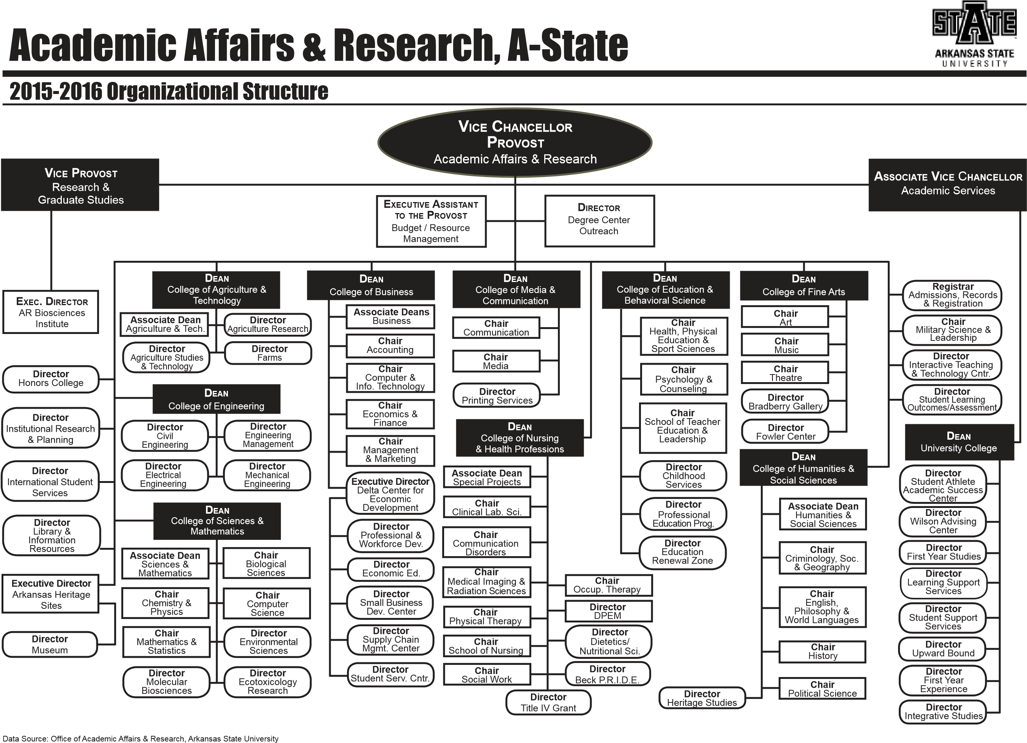

The proposed program will be housed in the Department of Computer Science in the College of Sciences and Mathematics.

Written Notification to Other Institutions
(referenced in # 17)

This should include a copy of written notification to other institutions in area of proposed program and responses

Enter text...

Student Learning Outcomes
Provide outcomes that students will accomplish during or at completion of this reconfigured degree. Fill out the following table to develop a continuous improvement assessment process.
For further assistance, please see the ‘Expanded Instructions’ document available on the UCC - Forms website for guidance, or contact the Office of Assessment at 870-972-2989.
Note: Best practices suggest 4-7 outcomes per program; minors would have 1 to 4 outcomes.
Outcome 1 | Students will have a broad exposure to concepts in computer science.
Assessment Measure | Comprehensive examinations and employer surveys
Which courses are responsible for this outcome? | CSED 5043, Principles of Computer Programming  CSED 5731, Principles of Abstract Structures  CSED 5231, Principles of Operating Systems  CSED 5241, Principles of Computer Organization  CS 5223, UNIX Systems Programming  CS 5313, Computer Networks  CS 5543, Database Systems
Assessment  Timetable | Comprehensive exams will be conducted each semester, reviewed annually, and reported on every three years; employer surveys will be conducted each fall and reported on every four years.
Who is responsible for assessing and reporting on the results? | Department of Computer Science assessment committee

Outcome 2 | Students will be able to think analytically in terms of understanding the nature of problems, crafting computer solutions for them, and evaluating those solutions.
Assessment Measure | Comprehensive examinations, student exit interview, and employer surveys
Which courses are responsible for this outcome? | CSED 5043, Principles of Computer Programming  CSED 5731, Principles of Abstract Structures  CSED 5231, Principles of Operating Systems  CSED 5241, Principles of Computer Organization  CS 5223, UNIX Systems Programming  CS 5313, Computer Networks  CS 5543, Database Systems
Assessment  Timetable | Comprehensive exams will be conducted each semester, reviewed annually, and reported on every three years; student exit interviews will be conducted each semester, reviewed annually, and reported on every three years; employer surveys will be conducted each fall and reported on every four years.
Who is responsible for assessing and reporting on the results? | Department of Computer Science assessment committee

Outcome 3 | Students will be able to communicate computer science concepts with clarity and effective exposition.
Assessment Measure | Comprehensive examinations, student exit interview and employer surveys
Which courses are responsible for this outcome? | CSED 5043, Principles of Computer Programming  CSED 5731, Principles of Abstract Structures  CSED 5231, Principles of Operating Systems  CSED 5241, Principles of Computer Organization
Assessment  Timetable | Comprehensive exams will be conducted each semester, reviewed annually, and reported on every three years; student exit interviews will be conducted each semester, reviewed annually, and reported on every three years; employer surveys will be conducted each fall and reported on every four years.
Who is responsible for assessing and reporting on the results? | Department of Computer Science assessment committee

Outcome 4 | Students will understand how educational philosophies impact teaching and student learning.
Assessment Measure | Comprehensive examinations and employer surveys
Which courses are responsible for this outcome? | ELFN 6763, Philosophies of Education  PSY 6513, Advanced Educational Psychology
Assessment  Timetable | Comprehensive exams will be conducted each semester, reviewed annually, and reported on every three years; employer surveys will be conducted each fall and reported on every four years.
Who is responsible for assessing and reporting on the results? | Department of Computer Science assessment committee

Outcome 5 | Students will understand the basic principles of learning and their applications to classroom management and instructional design.
Assessment Measure | Comprehensive examinations and employer surveys
Which courses are responsible for this outcome? | ELFN 6763, Philosophies of Education  PSY 6513, Advanced Educational Psychology
Assessment  Timetable | Comprehensive exams will be conducted each semester, reviewed annually, and reported on every three years; employer surveys will be conducted each fall and reported on every four years.
Who is responsible for assessing and reporting on the results? | Department of Computer Science assessment committee
Please repeat as necessary.

