For Academic Affairs and Research Use Only
CIP Code:
Degree Code:

Reconfiguration of Existing Degree Program Proposal Form
[ ] Undergraduate Curriculum Council
[X] Graduate Council
Signed paper copies of proposals submitted for consideration are no longer required. Please type approver name and enter date of approval.
Email completed proposals to curriculum@astate.edu for inclusion in curriculum committee agenda.
Gilbert Fowler 2/14/2018  Department Curriculum Committee Chair | __________________ Enter date  COPE Chair (if applicable)
Marceline Hayes 2/14/2018  Department Chair: | __________________ Enter date  Head of Unit (If applicable)
Warren Johnson 2/19/2018  College Curriculum Committee Chair | __________________ Enter date  Undergraduate Curriculum Council Chair
Gina Hogue 2/20/2018  College Dean | __________________ Enter date  Graduate Curriculum Committee Chair
__________________ Enter date  General Education Committee Chair (If applicable) | __________________ Enter date  Vice Chancellor for Academic Affairs

- Proposed Program Title
Master of Science in Strategic Communication

- Contact Person (Name, Email Address, Phone Number)
Dr. Holly Hall, Dept. of Communication, hollyhall@astate.edu, 870-972-3135

- Proposed Starting Date
Fall 2018

- Is there differential tuition requested? If yes, please fill out the New Program/Tuition and Fees Change Form.
No

Bulletin Changes

Instructions
Please visit http://www.astate.edu/a/registrar/students/bulletins/index.dot and select the most recent version of the bulletin. Copy and paste all bulletin pages this proposal affects below. Follow the following guidelines for indicating necessary changes.

*Please note: Courses are often listed in multiple sections of the bulletin. To ensure that all affected sections have been located, please search the bulletin (ctrl+F) for the appropriate courses before submission of this form.

- Deleted courses/credit hours should be marked with a red strike-through (red strikethrough)
- New credit hours and text changes should be listed in blue using enlarged font (blue using enlarged font).
- Any new courses should be listed in blue bold italics using enlarged font (blue bold italics using enlarged font)

You can easily apply any of these changes by selecting the example text in the instructions above, double-clicking the ‘format painter’ icon , and selecting the text you would like to apply the change to.
Please visit https://youtu.be/yjdL2n4lZm4 for more detailed instructions.

*For new programs, please insert copy of all sections where this is referenced.*

Insert Page 52 after Master of Science in Mass Communication (M.S.M.C.)

Master of Science in Mass Communications (M.S.M.C.)

Journalism
Radio-Television

Master of Science in Media Management (M.S.M.M.) Master of Science in Nursing (M.S.N.)

Adult Gerontology Clinical Nurse Specialist
—Nurse Administrator Option
—Nurse Educator Option

Family Nurse Practitioner
Nurse Anesthesia

Master of Science in Strategic Communication (M.S.S.C.)

Master of Social Work (M.S.W.)

Professional Science Masters (P.S.M.)

Biotechnology

[Insert Page 201 after the Radio-Television Master of Science in Mass Communications and before the Graduate Certificate in Health Communication]
University Requirements:
See Graduate Degree Policies for additional information (p. 35)
Program Requirements: | Sem. Hrs.
MDIA 6043, Theory of Mass Communications | 3
CMAC 6053, Quantitative Research Methods in Communications | 3
CMAC 6203, Introduction to Graduate Study | 3
CMAC 6253, Qualitative Research Methods in Communications | 3
Sub-total | 12
Journalism Requirements: | Sem. Hrs.
Select twelve hours from the following:  COMS 5113, Integrated Marketing Communication  COMS 5023, Public Opinion, Propaganda and the Mass Media  COMS 5603, Crisis Communication  COMS 6023, Advanced Studies in Communications Law  MDIA 5043, Studies in Newspaper Management  MDIA 5053, Public Affairs Reporting  MDIA 5083, Sports, Business and Opinion Writing  MDIA 5323, Race, Gender and Media  MDIA 5373, Internet Communications  MDIA 6083, Journalism Seminar  MDIA 680V, Independent Study | 12
Electives: | Sem. Hrs.
Advisor-approved Electives  May include six hours of thesis or project credit, courses in the college and/or courses outside  the college. The topic of the thesis or project is subject to approval by the student’s thesis or project committee. The thesis or project may be a continuation or extension of research begun in a Communications graduate class. | 6
Total Required Hours: | 30

Program of Study for the Master of Science in Strategic Communication Studies Degree
The Master of Science in Strategic Communication program provides a comprehensive foundation for a successful career in a wide range of communication fields. The program combines the foundational theories of effective communication with practical application to make an impact in a constantly changing media landscape.

Admission Requirements
Applicants seeking admission to the Master of Science degree in Strategic Communication must submit a sample of writing, which could be a recent term paper or research paper. With approval of the advisor, a student may complete up to six hours in cognate courses.
Strategic Communication
Master of Science
University Requirements:
See Graduate Degree Policies for additional information (p. 35)
Program Requirements: | Sem. Hrs.
COMS 6033, Media Regulation, Public Interest and the Law OR MDIA 6423, Media Entrepreneurship | 3
CMAC 6053, Quantitative Research Methods | 3
COMS 6253, Audience Market Analysis | 3
COMS 6263, Media Account Management | 3
COMS 6303, Seminar in Strategic Communications | 3
COMS 6533, Strategic Communication Management Capstone | 3
Select 4 of the following:  COMS 5113, Integrated Marketing Communication  COMS 5213, Social Media in Strategic Communication  COMS 5463, Interactive Advertising  COMS 5473, Social Media Measurement  COMS 5603, Crisis Communication  OR Approved Communication Studies Elective(s) (Students who have taken a 4000-level version of the above classes may substitute an approved Communication Studies Elective class.) | 12
Total Required Hours: | 30

LETTER OF NOTIFICATION – 11

RECONFIGURATION OF EXISTING DEGREE PROGRAMS
(Consolidation or Separation of Degrees to Create New Degree)
*Please include the documents to be submitted found throughout this LON at the end of the form.

- Institution submitting request: Arkansas State University-Jonesboro

- Contact person/title: Dr. Holly Hall, Associate Professor

- Title(s) of degree programs to be consolidated/reconfigured:
Master of Science in Media Management
Graduate Certificate in Health Communication
(Neither of these programs will be deleted.)

- Current CIP Code(s)/Current Degree Code(s): 09.0702, 09.0905

- Proposed title of consolidated/reconfigured program: Master of Science in Strategic Communication
- Proposed CIP Code for new program: 09.0999
- Proposed Effective Date: Fall 2018

- Reason for proposed program consolidation/reconfiguration:
(Indicate student demand (projected enrollment) for the proposed program and document that the program meets employer needs)

This online Master’s Degree in Strategic Communication is designed for those who want to excel in advertising, public relations, social media or corporate communication. Based on anecdotal evidence from recent graduates of our bachelor’s degree program, we believe the need for this master’s program exists. This program will help graduates successfully move on to a variety of fulfilling careers applying the strategic communication principles and skills they learned to jobs that run the gamut from business, government, and politics to entertainment, health, and social justice. Our program has specific communication expertise embedded in the curriculum emphasizing developing trends in social media. From the Bureau of Labor Statistics: “Employment of public relations specialists is projected to grow 9 percent from 2016 to 2026, about as fast as the average for all occupations. The need for organizations to maintain their public image will continue to drive employment growth.” (https://www.bls.gov/ooh/media-and-communication/public-relations-specialists.htm) Many potential students have undergraduate degrees in strategic communication areas, but received them at a time when social and digital media were not a part of the curriculum. A master’s degree will help our graduates stand out in this highly competitive and growing field. The rise of social and digital media is changing communication across industries, increasing the need for communication professionals with a diverse skill set whose messages get heard.

- Provide current and proposed curriculum outline by semester.
For undergraduate programs, please also fill out 8-semester plan at end of document.
Indicate total semester credit hours required for the proposed program. Underline new courses and provide new course descriptions. (If existing courses have been modified to create new courses, provide the course name/description for the current/existing courses and indicate the related new/modified courses.) Identify required general education core courses with an asterisk.
Master of Science in Media Management
Course Number | Course Name | Credit Hours
CMAC 6053 | Quantitative Research Methods in Mass Communication | 3
CMAC 6463 | Media Management Applications/Capstone | 3
COMS 6033 | Media Regulation, Public Interest & the Law | 3
COMS 6253 | Audience Marketing Analysis | 3
MDIA 6023 | Advanced Studies in Broadcast Management | 3
MDIA 6043 | Theory of Mass Communication | 3
Choose One Option
Mass Media Management (Select four of the following)
COMS 5113 | Integrated Marketing Communication | 3
COMS 5213 | Social Media in Strategic Communication | 3
COMS 5603 | Crisis Communication | 3
COMS 6263 | Media Account Management | 3
COMS 6413 | Organizational and Intercultural Communication | 3
MDIA 6423 | Media Entrepreneurship | 3
Public Administration (Select for of the following)
COMS 5213 | Social Media in Strategic Communication | 3
COMS 6263 | Media Account Management | 3
POSC 6543 | Administrative Behavior | 3
POSC 6563 | Seminar in Public Administration | 3
POSC 6593 | Seminar in Human Resource Management | 3
POSC 6613 | Administrative Leadership | 3
POSC 6623 | Administrative Ethics | 3
POSC 6633 | Public Information Management | 3
Social Media Management (Select four of the following)
COMS 5113 | Integrated Marketing Communication | 3
COMS 5213 | Social Media in Strategic Communication | 3
COMS 5463 | Interactive Advertising | 3
COMS 5473 | Social Media Measurement | 3
COMS 6263 | Media Account Management | 3
Total Hours |  | 30
Graduate Certificate in Health Communication
Course Number | Course Name | Credit Hours
NURS 6483 | Ethics in Health Care | 3
COMS 5402 | Seminar in Health Communication | 3
COMS 5243 OR COMS 6243 | Interpersonal Communication OR Seminar in Interpersonal Communication | 3
COMS 5253 | Intercultural Communication | 3
Electives
COMS 6303 | Seminar in Strategic Communications | 3
Elective | Elective | 3
Total Hours |  | 18
Proposed Master of Science in Strategic Communication
Semester 1
Course Number | Course Name | Credit Hours
CMAC 6053 | Quantitative Research Methods | 3
COMS 6303 | Seminar in Strategic Communications | 3
COMS 6253 | Audience Market Analysis | 3
COMS 6263 | Media Account Management | 3
Semester 2 (select four of the following)
COMS 5213 | Social Media in Strategic Communications | 3
COMS 5113 | Integrated Marketing Communication | 3
COMS 5463 | Interactive Advertising | 3
COMS 5473 | Social Media Measurement | 3
COMS 5603 | Crisis Communication | 3
Semester 3
COMS 6033 or MDIA 6423 | Media Regulation, Public Interest and the Law OR Media Entrepreneurship | 3
COMS 6533 | Strategic Communication Management Capstone | 3
Total Hours |  | 30
COMS 6533 Strategic Communication Management Capstone
Students will investigate a real-world strategic communication issue, formulating solutions, recommendations and strategies that bridge the gap between theory and practice. Course will be taken the final term of completing degree requirements.

- Provide program budget. Indicate amount of funds available for reallocation.
No new funds or resources are required for this degree program.

- Provide current and proposed organizational chart. See end of document.

- Institutional curriculum committee review/approval date: Enter text...

- Are the existing degrees offered off-campus or via distance delivery? The Master of Science in Media Management is offered via Distance Delivery

- Will the proposed degree be offered on-campus, off-campus, or via distance delivery?
The proposed program will be offered via Distance Delivery

- Identify mode of distance delivery or the off-campus location for the proposed program.
Blackboard Learn platform

- Provide documentation that proposed program has received full approval by licensure/certification entity, if required.
(A program offered for teacher/education administrator licensure must be reviewed/approved by the Arkansas Department of Education prior to consideration by the Coordinating Board; therefore, the Education Protocol Form also must be submitted to ADHE along with the Letter of Notification).

N/A

- Provide copy of e-mail notification to other institutions in the area of the proposed program and their responses; include your reply to the institutional responses. See end of document.

- List institutions offering similar program and identify the institutions used as a model to develop the proposed program.
Liberty University Online – M.A. in Strategic Communication
The University of Iowa – Master’s in Strategic Communication
Columbia University – M.S. in Strategic Communication
Michigan State University – M.A. in Strategic Communication Online
Model used to develop was courses taken from the M.S. in Media Management program

- Provide scheduled program review date (within 10 years of program implementation).
Fall 2028

- Provide additional program information if requested by ADHE staff.
Enter text...

President/Chancellor Approval Date: Click here to enter a date.
Board of Trustees Notification Date: Click here to enter a date.

Chief Academic officer: ___________________________________ Date: Enter date.
Name (printed): Click here to enter text.

Program Budget
(referenced in # 10)

Provide program budget. Indicate amount of funds available for reallocation.

Due to many of these courses being already being offered in AOS programs, no new funds or resources are required for this degree program

Organizational Chart
(referenced in # 11)

Provide current and proposed organizational chart. Include where the proposed program will be housed (department/college).

The program will be housed in the College of Liberal Arts and Communication Department of Communication
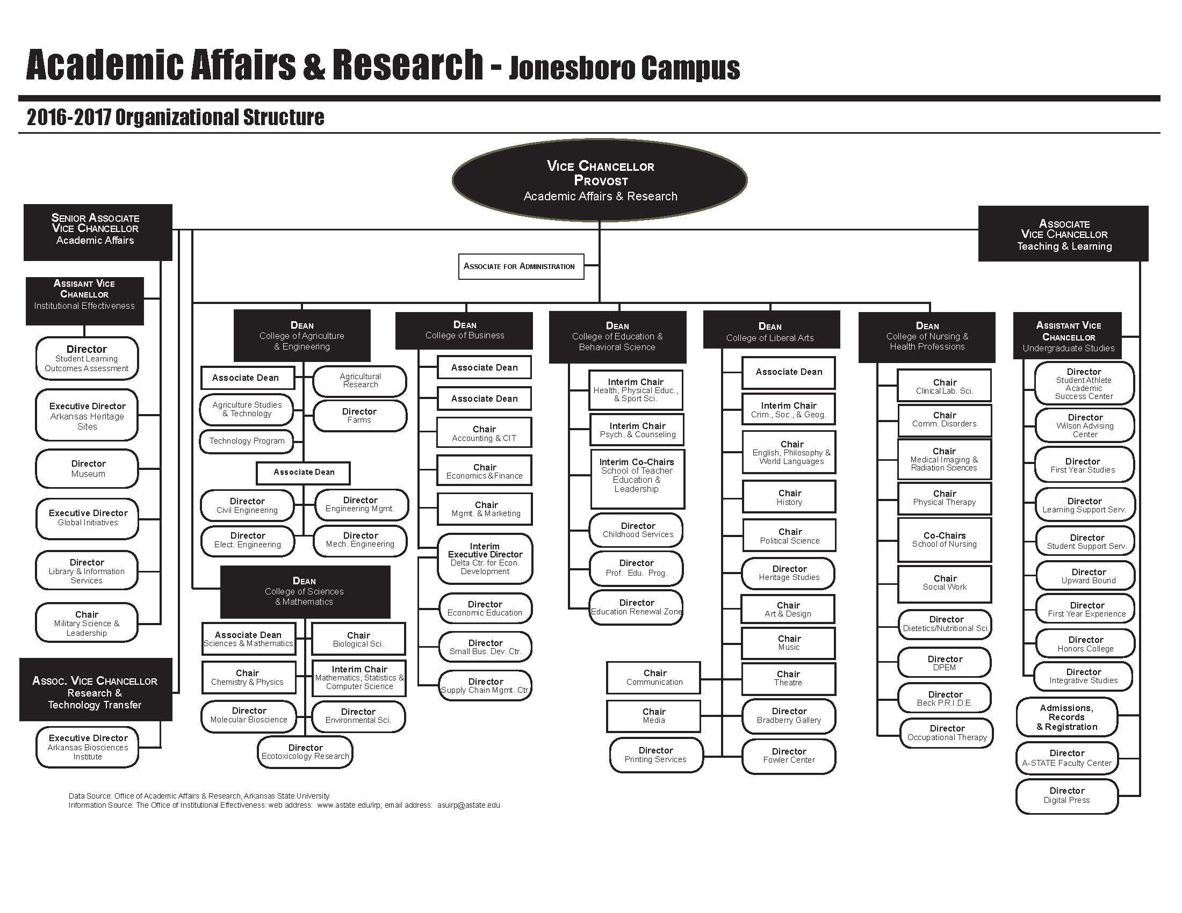

Written Notification to Other Institutions
(referenced in # 17)

This should include a copy of written notification to other institutions in area of proposed program and responses

Enter text...

Student Learning Outcomes
Provide outcomes that students will accomplish during or at completion of this reconfigured degree. Fill out the following table to develop a continuous improvement assessment process.
For further assistance, please see the ‘Expanded Instructions’ document available on the UCC - Forms website for guidance, or contact the Office of Assessment at 870-972-2989.
Note: Best practices suggest 4-7 outcomes per program; minors would have 1 to 4 outcomes.

Program Assessment

Outcome 1 | To apply theories of communications to problems of today.
Assessment Measure | Capstone experience
Which courses are responsible for this outcome? | COMS 6533 Strategic Communication Management Capstone
Assessment  Timetable | At the end of the capstone class. Results will be complied, analyzed and reported at the annual Strategic Communication faculty assessment meeting in December.
Who is responsible for assessing and reporting on the results? | Capstone class instructor, Strategic Communication Program Assessment Chair

Outcome 2 | To apply principles of research to problems and issues in communications
Assessment Measure | Capstone experience
Which courses are responsible for this outcome? | COMS 6533 Strategic Communication Management Capstone
Assessment  Timetable | At the end of the capstone class. Results will be complied, analyzed and reported at the annual Strategic Communication faculty assessment meeting in December.
Who is responsible for assessing and reporting on the results? | Capstone class instructor, Strategic Communication Program Assessment Chair

Please repeat as necessary.

