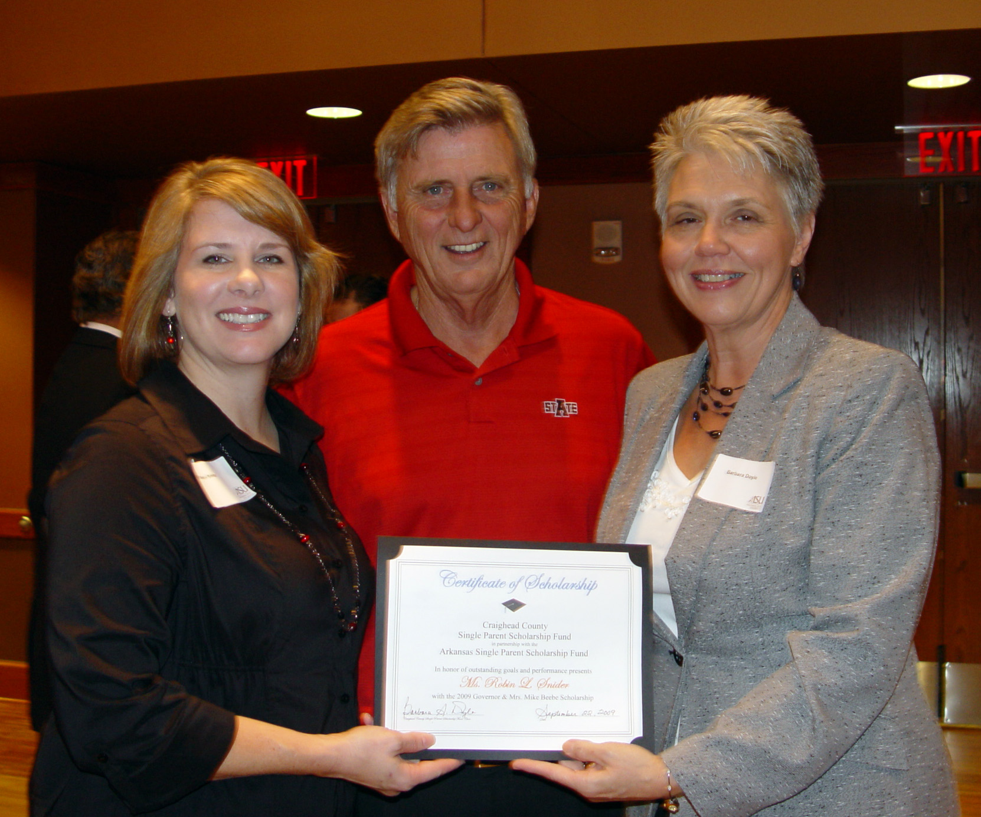
CUTLINE: Arkansas Governor Mike Beebe presents the first-ever scholarship for single parents to Arkansas State University student Robin Snider of Jonesboro (left). At right is Barbara Doyle, Director of Assessments at ASU.

For Release to the News Media:
October 1, 2009

ASU - Jonesboro: Jonesboro student receives first-ever Gov. Mike and Ginger Beebe Scholarship for single parents

Robin Snider, a full-time student at Arkansas State University, is the first-ever recipient of the Governor Mike and Ginger Beebe Single Parent Scholarship, which was recently awarded. Snider, a life-long resident of Craighead County and a native of Jonesboro, is part of the Communications Disorders program at ASU’s College of Nursing and Health Professions.
Snider, a freshman, will receive the scholarship for the fall semester. She has three children—daughter Hailie, 23, a sophomore psychology major at ASU; 19-year-old Chase, a sophomore at ASU majoring in Exercise Science; and 16-year-old Alex, a junior at Valley View High School. Snider also works full-time at the Arkansas Parent Training and Information Center in Jonesboro, a federally funded program through the state department of education.
The $1,000 scholarship donation was issued by the Arkansas Single Parent Scholarship Fund to the Craighead County Single Parent Scholarship Fund in honor of the Governor and Mrs. Beebe. Gov. Beebe is a graduate of Arkansas State. The money is split into two scholarships, one to be awarded in the fall and the second in the spring semester. The spring award will go through another application review.
The scholarship’s purpose is to provide supplemental financial assistance to those single parents with a 2.5 or better grade point average who pursue a course of instruction that will improve income earning potential.

