CITIES VISITED: BARCELONA, NICE, CINQUE TERRE, FLORENCE
PROGRAM NUMBER:  2091620CM | LENGTH:  10 DAY PROGRAM
MAY 27
MAY 14 — MAY 23
MAY 12
ENROLL ONLINE: EFCST.COM/2091620CM

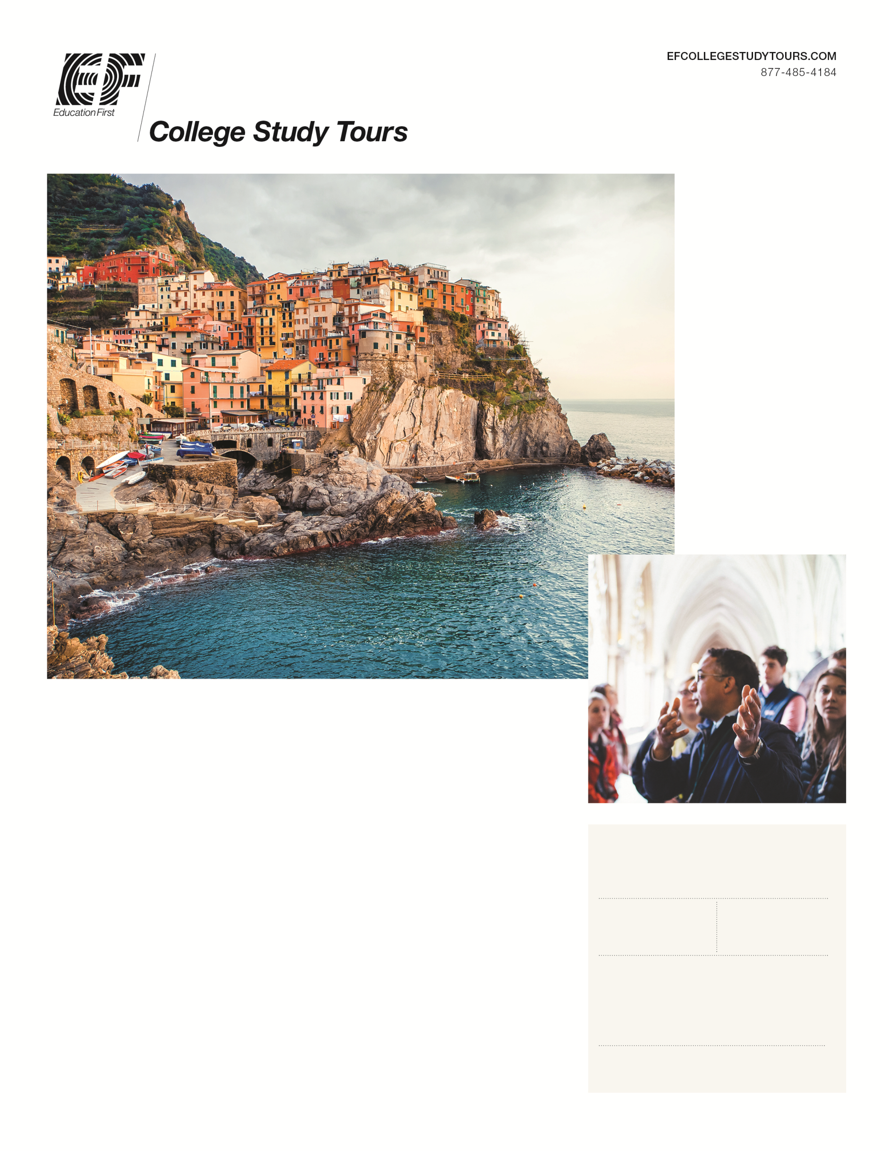

Barcelona, Southern France & Italy
LED BY ALEXIS HURDLE
ARKANSAS STATE UNIVERSITY
___

Built on a raw imagination and boundless individuality, Barcelona provokes inspiration and curiosity from each of its visitors. Whether it's the architecture of Gaudí defining a street corner or the narrow barrios inviting you to take a closer look—every inch of this city is waiting to be discovered. For a creative spirit traveling through Carcassonne into Nice, it doesn't take long to notice that its rustic atmosphere inspires more than just idle admiration.

“This experience pushed me out of my comfort zone. I never imagined traveling abroad, but travling with EF Tours made the experience so easy, enjoyable, and comfortable. A-State's GSL program gave me memories and friendships that I wouldn't trade for the world!”

– JENI F. 2019 A-STATE GSL PARTICIPANT

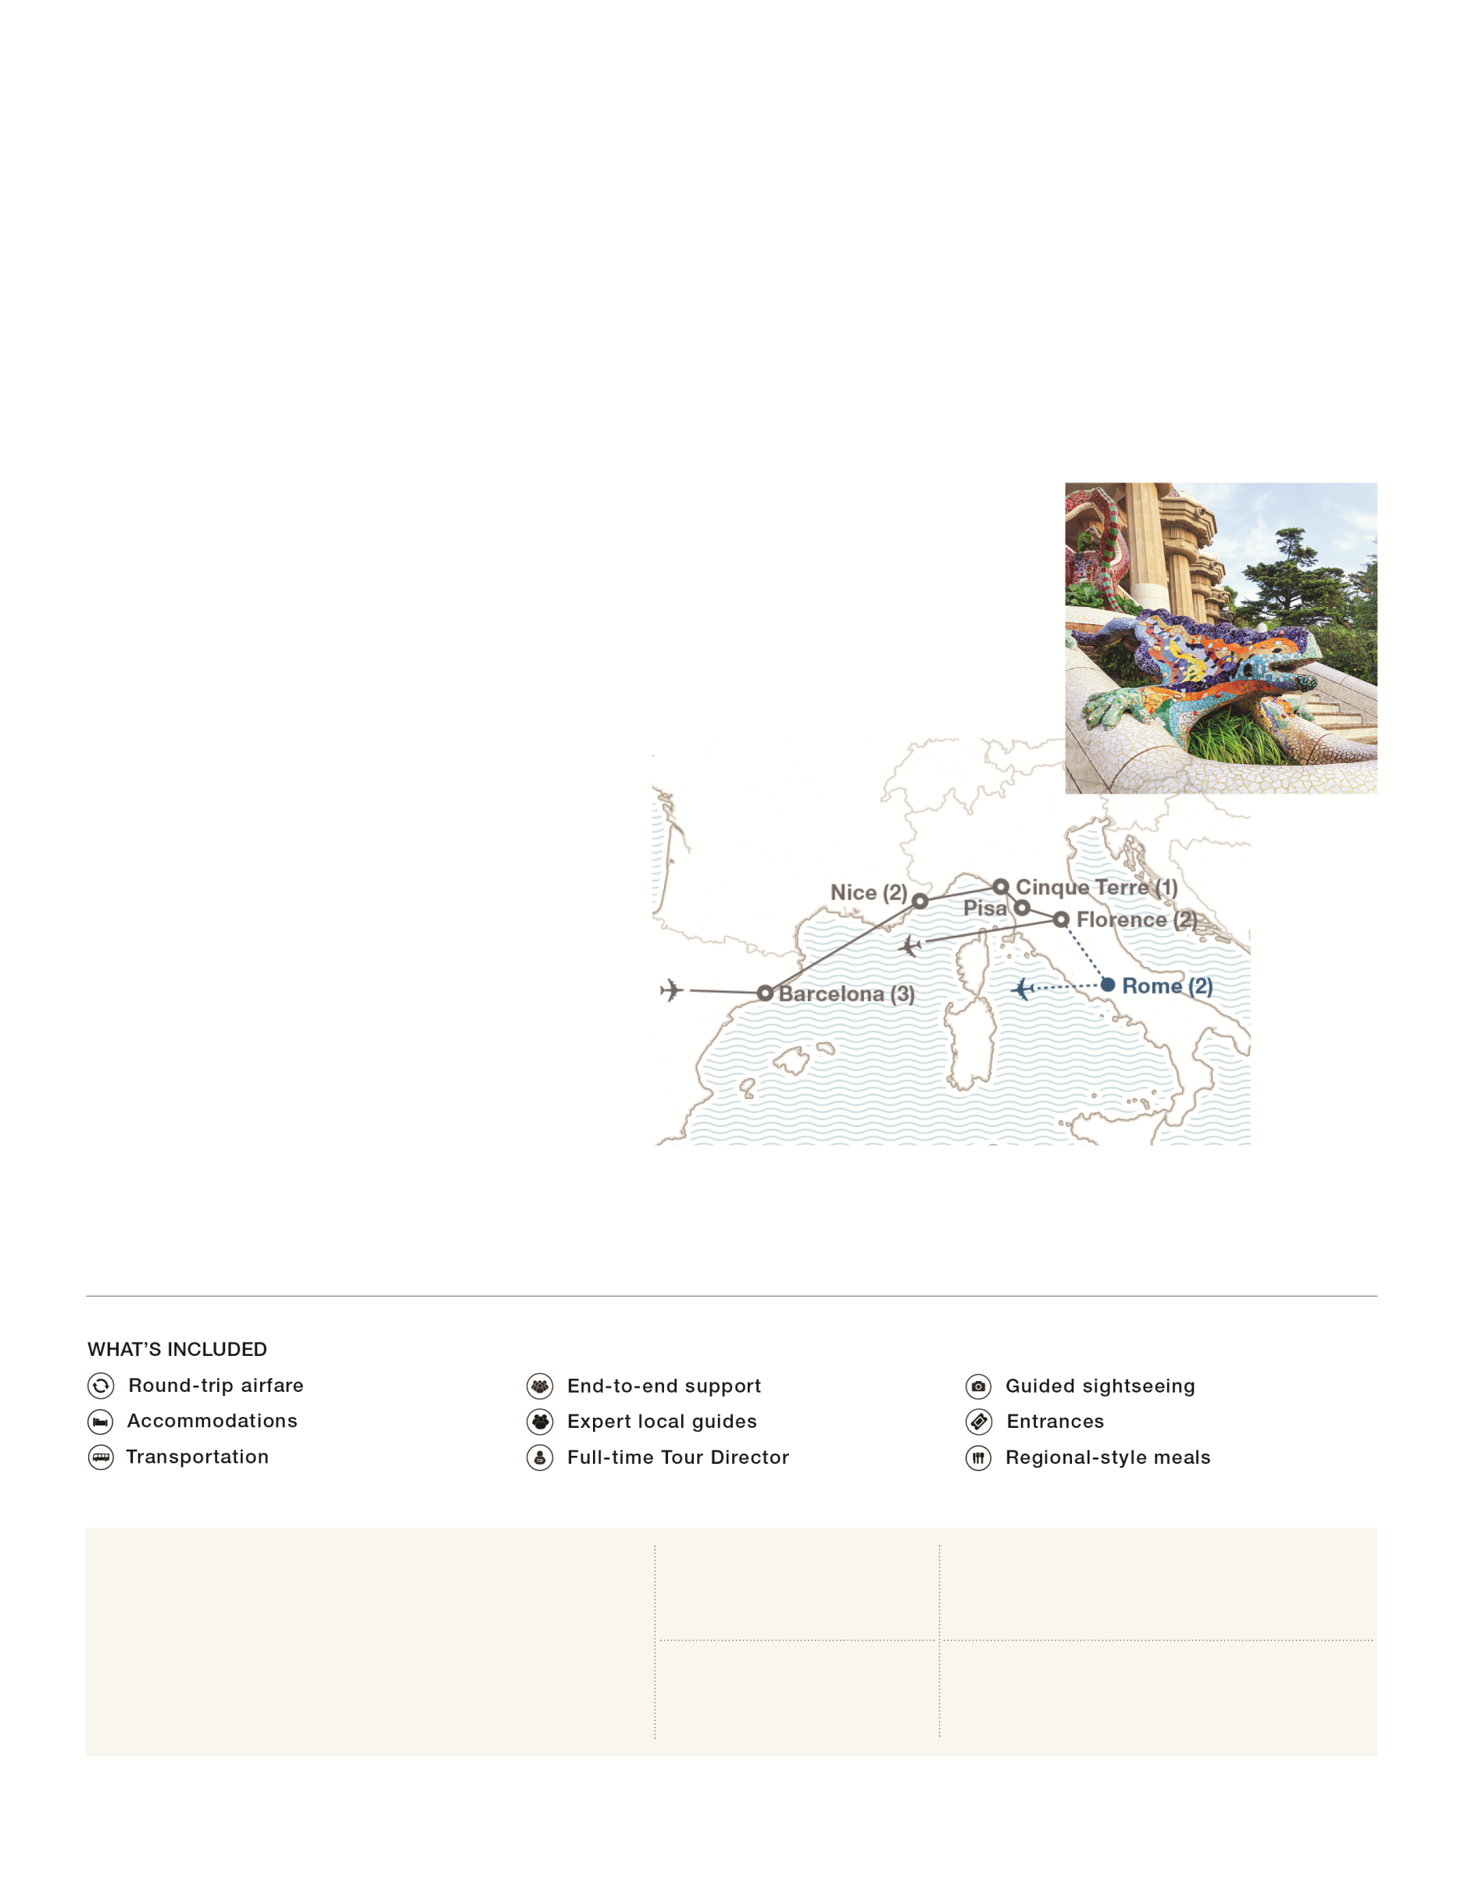

10-DAY ITINERARY

Day 1: Fly overnight to Spain
Day 2: Barcelona
- Meet your Tour Director at the airport
- Take a walking tour of Las Ramblas
- Enjoy dinner in Barcelona
Day 3: Barcelona
- Take a guided tour of Barcelona
- See La Sagrada Família
- See Montjuïc
- Visit the Gothic Quarter
- See Barcelona Cathedral
- Visit Park Güell
Day 4: Barcelona
- Tour La Boquería market with an expert local guide
- Enjoy a tapas lunch in Barcelona
- Take an optional excursion to the Dalí Museum
Day 5: Barcelona • Carcassonne • French Riviera
- Travel via Carcassonne to the French Riviera
- Take a tour of Carcassonne
- Enjoy dinner in the French Riviera
Day 6: French Riviera • Nice
- Take a day trip to Monaco and Èze
- Visit a French perfume factory in Èze
- Take a walking tour of Nice
Day 7: French Riviera • Cinque Terre
- Travel to Cinque Terre
- Explore Cinque Terre by boat
- Enjoy dinner at your hotel
Day 8: Cinque Terre • Pisa • Florence
- Travel via Pisa to Florence
- See the Leaning Tower of Pisa
- Visit the Baptistery of St. John and the Pisa Cathedral
Day 9: Florence
- Take a guided tour of Florence
- See Piazza della Signoria
- See Ponte Vecchio
- Visit the Duomo
- Enjoy dinner in Florence
Day 10: Depart for home

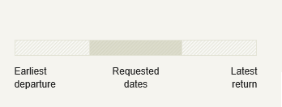  REQUESTED DEPARTURE DATE – SUBJECT TO CHANGE:  MAY 14 — MAY 23  MAY 27  MAY 12 | DEPARTURE CITY:  MEMPHIS - MEM | ENROLL BY PHONE:  877-485-4184
 | PROGRAM NUMBER:  2091620CM | ENROLL ONLINE:  EFCST.COM/2091620CM
*PROGRAM PRICE VALID FOR TODAY. DOUBLE ROOMING IS REQUIRED FOR TRAVELERS AGE 30 AND OLDER AT THE TIME OF TRAVEL. CHANGE AND CANCELLATION FEES OF UP TO THE TOTAL PRICE WILL APPLY. APPLICABLE AIRLINE BAGGAGE FEES ARE NOT INCLUDED AND CAN BE FOUND AT EFCOLLEGESTUDYTOURS.COM/BAGGAGE. ALL PRICES SUBJECT TO VERIFICATION BY EF PROGRAM COORDINATOR. TO VIEW EF’S BOOKING CONDITIONS, VISIT EFCOLLEGESTUDYTOURS.COM/BC.
ENROLL NOW

EFCOLLEGESTudytours.com/2091620CM

