Code # Enter text…

**New Course Proposal Form**

**[X] Undergraduate Curriculum Council**

**[ ] Graduate Council**

|  |
| --- |
| **[ ] New Course or [ ]Experimental Course (1-time offering) (Check one box)** |

Signed paper copies of proposals submitted for consideration are no longer required. Please type approver name and enter date of approval.

Email completed proposals to [curriculum@astate.edu](mailto:curriculum@astate.edu) for inclusion in curriculum committee agenda.

|  |  |
| --- | --- |
| Sharon James 1/16/2017 **Department Curriculum Committee Chair** | ___________________ Enter date…  **COPE Chair (if applicable)** |
| Melodie Philhours 1/18/2017 **Department Chair:** | ___________________ Enter date…  **Head of Unit (If applicable)** |
| John Seydel 2/3/2017 **College Curriculum Committee Chair** | ___________________ Enter date…  **Undergraduate Curriculum Council Chair** |
| C. Shane Hunt 2/22/2017 **College Dean** | ___________________ Enter date…  **Graduate Curriculum Committee Chair** |
| |  |  | | --- | --- | | __________________ | Enter date |   **General Education Committee Chair (If applicable)** | ___________________ Enter date…  **Vice Chancellor for Academic Affairs** |

1. Contact Person (Name, Email Address, Phone Number)

Dr. Melodie Philhours, [mphil@astate.edu](mailto:mphil@astate.edu), 870-680-8148

2. Proposed Starting Term and Bulletin Year

Spring 2018

3. Proposed Course Prefix and Number (Confirm that number chosen has not been used before. For variable credit courses, indicate variable range. *Proposed number for experimental course is 9*. )

MKTG 4253

4. Course Title – if title is more than 30 characters (including spaces), provide short title to be used on transcripts. Title cannot have any symbols (e.g. slash, colon, semi-colon, apostrophe, dash, and parenthesis). Please indicate if this course will have variable titles (e.g. independent study, thesis, special topics).

Data Analytics and Visualization

Short Title: Data Analytics Visualization

5. Brief course description (40 words or fewer) as it should appear in the bulletin.

Examination and application of procedures to extract the right marketing data from the right sources, analyze this data using the right tools/techniques and present the resultant current, relevant, and accurate information in clear visual format that supports strategic decision making.

6. Prerequisites and major restrictions. (Indicate all prerequisites. If this course is restricted to a specific major, which major. If a student does not have the prerequisites or does not have the appropriate major, the student will not be allowed to register).

1. Are there any prerequisites? Yes
   1. If yes, which ones?

MKTG 3013 Marketing

* 1. Why or why not?

MKTG 3013 Marketing is the introductory marketing course. This basic knowledge is necessary to achieve maximum understanding and value from this proposed course.

1. Is this course restricted to a specific major? No
   1. If yes, which major? Enter text...

7. Course frequency(e.g. Fall, Spring, Summer). *Not applicable to Graduate courses.*

Spring

8. Will this course be lecture only, lab only, lecture and lab, activity, dissertation, experiential learning, independent study, internship, performance, practicum, recitation, seminar, special problems, special topics, studio, student exchange, occupational learning credit, or course for fee purpose only (e.g. an exam)? Please choose one.

Lecture and lab

9. What is the grade type (i.e. standard letter, credit/no credit, pass/fail, no grade, developmental, or other [please elaborate])

Standard Letter

10. Is this course dual listed (undergraduate/graduate)?

No

11. Is this course cross listed? (If it is, all course entries must be identical including course descriptions. It is important to check the course description of an existing course when adding a new cross listed course.)

No

1. If yes, please list the prefix and course number of cross listed course.

Enter text...

1. Are these courses offered for equivalent credit? Yes / No

Please explain. Enter text...

12. Is this course in support of a new program? Yes

a. If yes, what program?

BS Marketing, Marketing Analytics Emphasis

13. Does this course replace a course being deleted? No

a. If yes, what course?

Enter text...

14. Will this course be equivalent to a deleted course? No

a. If yes, which course?

Enter text...

15. Has it been confirmed that this course number is available for use? Yes

*If no: Contact Registrar’s Office for assistance.*

16. Does this course affect another program? No

If yes, provide contact information from the Dean, Department Head, and/or Program Director whose area this affects.

Enter text...

**Course Details**

17. Outline (The course outline should be topical by weeks and should be sufficient in detail to allow for judgment of the content of the course.)

Week 1 – An introduction into Data Analytics and Visualization.

Week 2 – Visualizing data with charts in Microsoft Excel.

Week 3 – Analyzing stock trades and market performance data in Microsoft Excel.

Week 4 – Working with Pivot Tables and Pivot Charts in Microsoft Excel.

Week 5 – Communicating correlation and regression data in Microsoft Excel.

Week 6 – Creating indicator heat maps using data conditional formatting in Microsoft Excel.

Week 7 – Overview of Watson Analytics and other big data analytics tools.

Week 8 – Watson Analytics: Identifying data structure limitations, loading data from flat files.

Week 9 – Watson Analytics: Loading and analyzing data from databases and social media datasets.

Week 10 – Watson Analytics: Data manipulation, calculation and drilling down hierarchical data.

Week 11 – Watson Analytics: Pattern discovery, analyzing decision rules and predictive analysis.

Week 12 – Watson Analytics: Adding value to analysis through social commentaries and emails.

Week 13 – Watson Analytics: Working with visualization types, modifying and filtering visualization displays.

Week 14 – Watson Analytics: Sharing assets and permissions.

18. Special features (e.g. labs, exhibits, site visitations, etc.)

Enter text...

19. Department staffing and classroom/lab resources

Current faculty; computer lab classroom

1. Will this require additional faculty, supplies, etc.?

As the program grows, additional faculty may be needed to support course offerings.

20. Does this course require course fees? No

*If yes: please attach the New Program Tuition and Fees form, which is available from the UCC website.*

**Course Justification**

21. Justification for course being included in program. Must include:

a. Academic rationale and goals for the course (skills or level of knowledge students can be expected to attain)

Marketing is an increasingly technical field and to ready marketing students to be competitive, research-driven, analytical, digital and tech skills are imperative. In consultation with practicing marketing professionals, skill gaps were recognized in analytical, digital, and tech skills. To fill this gap in the current marketing curriculum, this course is being piloted as MKTG 419V Special Problems in Spring 2017.

b. How does the course fit with the mission established by the department for the curriculum? If course is mandated by an accrediting or certifying agency, include the directive.

The mission of the College of Business is to provide high quality management education to include fostering analytical thinking and problem solving. The mission of the Department of Marketing and Management includes preparing students to create and implement marketing strategies within a wide variety of industries. This course addresses and enhances student learning consistent with the core goals of the College of Business including the use of technology, communication skills, ethics, business knowledge, and critical thinking. Additionally, the course supports the BS Marketing learning goals to include marketing knowledge, digital savvy, and research and analytical skills, all of which are necessary to create and implement modern marketing strategies. Additionally, AACSB accreditation emphasizes ‘current expertise’ as important within the business curriculum.

c. Student population served.

Upper Level Undergraduate

d. Rationale for the level of the course (lower, upper, or graduate).

A foundation of lower level business courses as well as MKTG 3013 Marketing is needed to gain maximum value from this course. This supports the designation of this course as upper level.

**Assessment**

**University Outcomes**

22. Please indicate the university-level student learning outcomes for which this new course will contribute. Check all that apply.

|  |  |  |
| --- | --- | --- |
| * 1. **[ ]** Global Awareness | * 1. **[ ]** Thinking Critically | * 1. **[X]** Information Literacy |

**Relationship with Current Program-Level Assessment Process**

23. What is/are the intended program-level learning outcome/s for students enrolled in this course? Where will this course fit into an already existing program assessment process?

Depth of Marketing Knowledge

Digital Savvy

Analytical/Research-driven Skills

24. Considering the indicated program-level learning outcome/s (from question #23), please fill out the following table to show how and where this course fits into the program’s continuous improvement assessment process.

*For further assistance, please see the ‘Expanded Instructions’ document available on the UCC - Forms website for guidance, or contact the Office of Assessment at 870-972-2989.*

|  |  |
| --- | --- |
| **Program-Level Outcome 1 (from question #23)** | Depth of Marketing Knowledge |
| Assessment Measure | ETS – Major Field Test of Business – marketing subscores for marketing majors |
| Assessment  Timetable | Spring 2017 and every two years going forward in MGMT 4813 Strategic Management (capstone business course) |
| Who is responsible for assessing and reporting on the results? | Dr. Melodie Philhours and the faculty Business Knowledge Goal Assessment Team |

|  |  |
| --- | --- |
| **Program-Level Outcome 2 (from question #23)** | Digital Savvy |
| Assessment Measure | Final individual projects in MKTG 4223 Marketing Management will be evaluated by instructor. Results will be evaluated using instructor grading scale and B or better will be considered acceptable for marketing majors. All students will be evaluated and marketing majors will be selected for specific data collection. |
| Assessment  Timetable | Every two years beginning Spring 2018 |
| Who is responsible for assessing and reporting on the results? | Instructor of course and Marketing Faculty |

|  |  |
| --- | --- |
| **Program-Level Outcome 3 (from question #23)** | Analytical/Research-driven Skills |
| Assessment Measure | Individual projects in MKTG 3023 Applied Research will be evaluated by Dr. Nonis, professor for this course. Results will be evaluated using Dr. Nonis’ grading scale. B or better will be considered acceptable for marketing majors. Other CoB majors are required to take this course. All students will be evaluated and marketing majors will be selected for specific data collection. |
| Assessment  Timetable | Every two years beginning Spring 2017 |
| Who is responsible for assessing and reporting on the results? | Dr. Sarath Nonis and Marketing Faculty |

*(Repeat if this new course will support additional program-level outcomes)*

**Course-Level Outcomes**

25. What are the course-level outcomes for students enrolled in this course and the associated assessment measures?

|  |  |
| --- | --- |
| **Outcome 1** | Understand the basic concepts of data analytics and visualization tools and techniques. |
| Which learning activities are responsible for this outcome? | Lecture, labs, readings, homework, and in class activities using Excel and IBM Watson Analytics data analysis and visualization tools. |
| Assessment Measure | 3 quizzes, 11 lab assignments, presentation, mid-term and final exams. Specifically, the final presentation in MKTG 4253 Data Analytics and Visualization will be evaluated using instructor grading scale. B or better will be considered acceptable for marketing majors. Marketing majors will be selected for specific data collection as the course is open to other majors as well. |

|  |  |
| --- | --- |
| **Outcome 2** | Demonstrate the ability to analyze, compute, and visually present market decision data using multiple data sources in Microsoft Excel. |
| Which learning activities are responsible for this outcome? | Lecture, labs, readings, homework, and in class activities using Excel and IBM Watson Analytics data analysis and visualization tools. |
| Assessment Measure | 3 quizzes, 11 lab assignments, presentation, mid-term and final exams. Specifically, the final presentation in MKTG 4253 Data Analytics and Visualization will be evaluated using instructor grading scale. B or better will be considered acceptable for marketing majors. Marketing majors will be selected for specific data collection as the course is open to other majors as well. |

|  |  |
| --- | --- |
| **Outcome 3** | Demonstrate the ability to interpret business data and perform pattern discovery, analyze decision rules, and perform predictive analysis. |
| Which learning activities are responsible for this outcome? | Lecture, labs, readings, homework, and in class activities using Excel and IBM Watson Analytics data analysis and visualization tools. |
| Assessment Measure | 3 quizzes, 11 lab assignments, presentation, mid-term and final exams. Specifically, the final presentation in MKTG 4253 Data Analytics and Visualization will be evaluated using instructor grading scale. B or better will be considered acceptable for marketing majors. Marketing majors will be selected for specific data collection as the course is open to other majors as well. |

*(Repeat if needed for additional outcomes)*

**Bulletin Changes**

|  |
| --- |
| **Instructions** |
| **Please visit** [**http://www.astate.edu/a/registrar/students/bulletins/index.dot**](http://www.astate.edu/a/registrar/students/bulletins/index.dot) **and select the most recent version of the bulletin. Copy and paste all bulletin pages this proposal affects below. Follow the following guidelines for indicating necessary changes.**  **\*Please note: Courses are often listed in multiple sections of the bulletin. To ensure that all affected sections have been located, please search the bulletin (ctrl+F) for the appropriate courses before submission of this form.**  - Deleted courses/credit hours should be marked with a red strike-through (~~red strikethrough~~)  - New credit hours and text changes should be listed in blue using enlarged font (blue using enlarged font).  - Any new courses should be listed in blue bold italics using enlarged font (***blue bold italics using enlarged font***)  *You can easily apply any of these changes by selecting the example text in the instructions above, double-clicking the ‘format painter’ icon 🡪 , and selecting the text you would like to apply the change to.*  *Please visit* [*https://youtu.be/yjdL2n4lZm4*](https://youtu.be/yjdL2n4lZm4) *for more detailed instructions.* |

PAGE 443:

MKTG 4213. Marketing Analytics Students will harness the power of data in the marketing

management decision process in a digital environment using analytics to identify/target profitable

customers, expand relationships and share of business through analysis of customer digital behavior,

spend data, and preferences. Prerequisite, MKTG 3013. Fall.

**MKTG 4223. Marketing Management** Evaluation and analysis of marketing strategies in competitive

situations. Course examines various price, product, distribution, and promotion strategies that

are essential to firms. Focus on the integration and assessment of these elements in developing

and adapting a successful marketing strategy. Prerequisite, MKTG 3013. Fall, Spring, Demand.

*MKTG 4253 Data Analytics and Visualization Examination and application of procedures to extract the right data from the right sources, analyze this data using the right tools/techniques and present the resultant current, relevant, and accurate information in a clear visual format that supports strategic decision making. Prerequisite, MKTG 3013. Spring.*

**MKTG 4263. Sales Internship**  Internship credit for students with a declared major in Marketing.

Prerequisites, The student must have completed nine upper level hours in the marketing major,

junior standing and permission of instructor. Fall, Spring, Summer.

BETWEEN PAGES 167 AND 168:

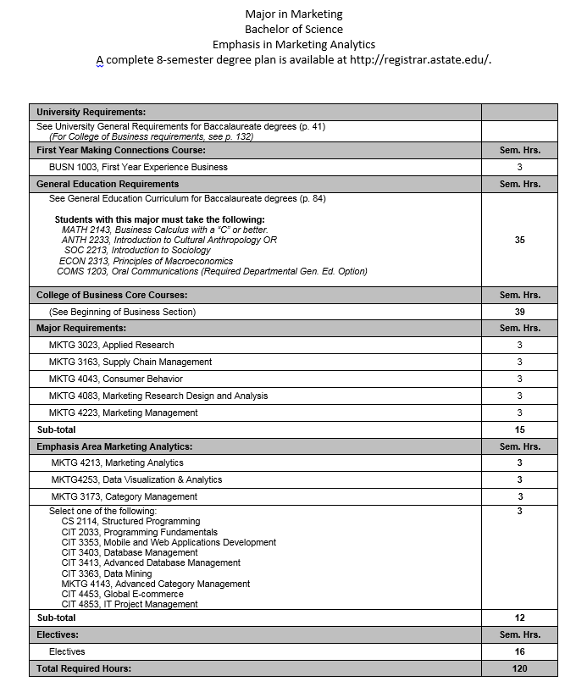



Major in Marketing

**Bachelor of Science**

**Emphasis in Logistics**

A complete 8-semester degree plan is available at http://registrar.astate.edu/.

|  |  |
| --- | --- |
| University Requirements: | |
| See University General Requirements for Baccalaureate degrees (p. 42)  *(For College of Business requirements, see p. 132)* | |
| **First Year Making Connections Course:** | Sem. Hrs. |
| BUSN 1003, First Year Experience Business | 3 |
| **General Education Requirements:** | Sem. Hrs. |
| See General Education Curriculum for Baccalaureate degrees (p. 84)  Students with this major must take the following:  *MATH 2143, Business Calculus with a “C” or better.*  *ANTH 2233, Introduction to Cultural Anthropology OR*  *SOC 2213, Introduction to Sociology*  *ECON 2313, Principles of Macroeconomics*  *COMS 1203, Oral Communication (Required Departmental Gen. Ed. Option)* | 35 |
| **College of Business Core Courses:** | Sem. Hrs. |
| (See Beginning of Business Section) | 39 |
| **Major Requirements:** | Sem. Hrs. |
| MKTG 3023, Applied Research | 3 |
| MKTG 3163, Supply Chain Management | 3 |
| MKTG 4043, Consumer Behavior | 3 |
| MKTG 4083, Marketing Research Design and Analysis | 3 |
| MKTG 4223, Marketing Management | 3 |
| Sub-total | 15 |
| **Emphasis Area (Logistics):** | Sem. Hrs. |
| MKTG 3063, Transportation | 3 |
| MKTG 4103, Concepts of Business Logistics | 3 |
| MKTG 4133, International Logistics and Outsourcing | 3 |
| Select one of the following:  ACCT 3053, Cost Accounting with a Managerial Emphasis  BCOM 3573, Managerial Communication  ECON 4333, Government Regulation of Business  ECON 4343, Managerial Economics  MGMT 4123, International Management  MKTG 3043, Retailing  MKTG 3093, Professional Selling  MKTG 4123, Organizational Purchasing  MKTG 4273, Supply Chain Management Internship | 3 |
| Sub-total | 12 |
| **Electives:** | Sem. Hrs. |
| Electives | 16 |
| **Total Required Hours:** | **120** |